GRAFFIAU DADLEOLIAD - PELLTER

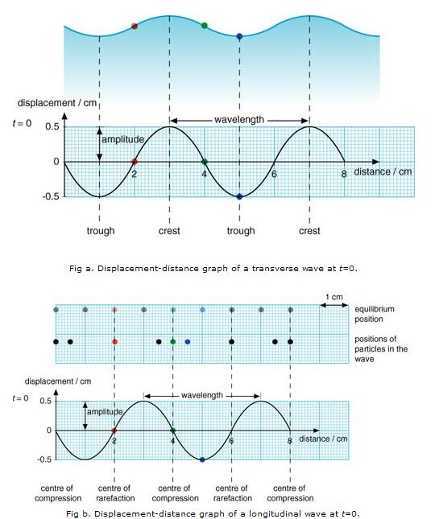

GRAFFIAU DADLEOLIAD - AMSER

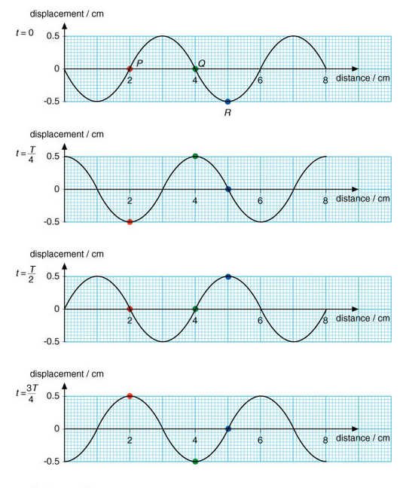

O: http://sciencecity.oupchina.com.hk/npaw/student/supplementary/1c-graph.asp

